WEEK 1

MODULE 1 : Design Patterns and Principles

Name : Sudarmani V
Superset Id : 6737805

Exercise 1 : Implementing the Singleton Pattern
Code :
class Logger {
private static Logger instance;

private Logger() {}

public static Logger getInstance() {
if (instance == null) {
instance = new Logger();
}
return instance;
}

public void log(String message) {
System.out.println("[LOG] " + message);
}
}

public class ImplementingSingletonPattern_6737805 {
public static void main(String[] args) {
Logger logger1 = Logger.getInstance();
Logger logger2 = Logger.getInstance();

logger1.log("Application started");
logger2.log("User logged in");

if (logger1 == logger2) {
System.out.println("Both logger1 and logger2 are the SAME instance.");
} else {
System.out.println("Different instances — Singleton failed!");
}
}
}
Output :
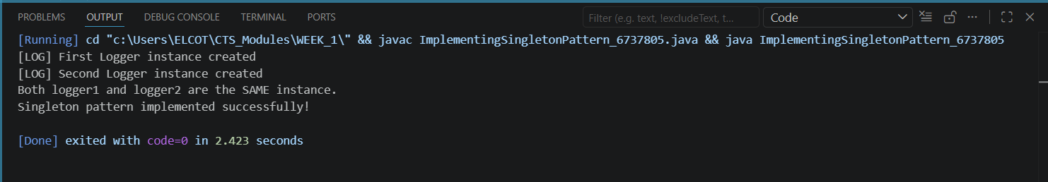

Exercise 2 : Implementing the Factory Method Pattern
Code :
interface Document {
void open();
void save();
void close();
}

class WordDocument implements Document {
public void open() {
System.out.println("Opening Word Document (.docx)");
}
public void save() {
System.out.println("Saving Word Document (.docx)");
}
public void close() {
System.out.println("Closing Word Document (.docx)");
}
}

class PdfDocument implements Document {
public void open() {
System.out.println("Opening PDF Document (.pdf)");
}
public void save() {
System.out.println("Saving PDF Document (.pdf)");
}
public void close() {
System.out.println("Closing PDF Document (.pdf)");
}
}

class ExcelDocument implements Document {
public void open() {
System.out.println("Opening Excel Document (.xlsx)");
}
public void save() {
System.out.println("Saving Excel Document (.xlsx)");
}
public void close() {
System.out.println("Closing Excel Document (.xlsx)");
}
}

abstract class DocumentFactory {
public abstract Document createDocument();

public void manageDocument() {
Document doc = createDocument();
doc.open();
doc.save();
doc.close();
}
}

class WordDocumentFactory extends DocumentFactory {
public Document createDocument() {
return new WordDocument();
}
}

class PdfDocumentFactory extends DocumentFactory {
public Document createDocument() {
return new PdfDocument();
}
}

class ExcelDocumentFactory extends DocumentFactory {
public Document createDocument() {
return new ExcelDocument();
}
}

public class ImplementingFactoryMethod_6737805 {
public static void main(String[] args) {
System.out.println("=== Document Management System ===\n");

DocumentFactory wordFactory = new WordDocumentFactory();
System.out.println("--- Word Document ---");
wordFactory.manageDocument();

System.out.println();

DocumentFactory pdfFactory = new PdfDocumentFactory();
System.out.println("--- PDF Document ---");
pdfFactory.manageDocument();

System.out.println();

DocumentFactory excelFactory = new ExcelDocumentFactory();
System.out.println("--- Excel Document ---");
excelFactory.manageDocument();
}
}

Output :
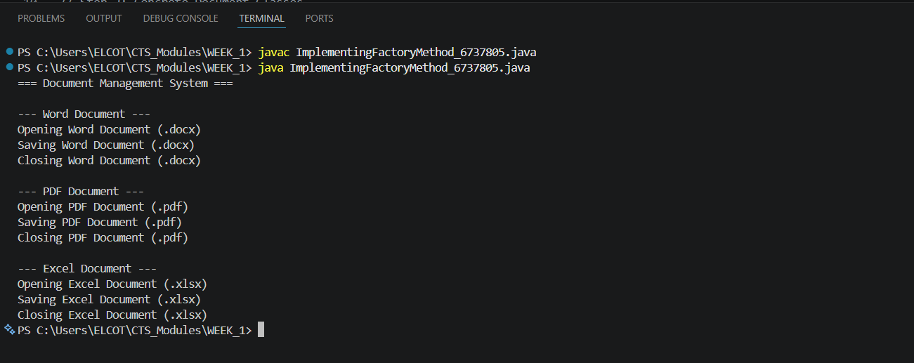

Exercise 3 : Implementing the Builder Pattern
Code :
package BuilderPatternExample;

public class ImplementingBuilderPattern_6737805 {

private final String cpu;
private final String ram;
private final String storage;
private final String graphicsCard;
private final String os;

private ImplementingBuilderPattern_6737805(Builder builder) {
this.cpu = builder.cpu;
this.ram = builder.ram;
this.storage = builder.storage;
this.graphicsCard = builder.graphicsCard;
this.os = builder.os;
}

public void showSpecs() {
System.out.println("Computer Specs:");
System.out.println("CPU: " + cpu);
System.out.println("RAM: " + ram);
System.out.println("Storage: " + (storage != null ? storage : "Not specified"));
System.out.println("Graphics Card: " + (graphicsCard != null ? graphicsCard : "Not specified"));
System.out.println("OS: " + (os != null ? os : "Not specified"));
}

@Override
public String toString() {
return "Computer {" +
"\n CPU = " + cpu +
"\n RAM = " + ram +
"\n Storage = " + (storage != null ? storage : "Not specified") +
"\n Graphics Card = " + (graphicsCard != null ? graphicsCard : "Not specified") +
"\n OS = " + (os != null ? os : "Not specified") +
"\n}";
}

public static class Builder {

private final String cpu;
private final String ram;
private String storage;
private String graphicsCard;
private String os;

public Builder(String cpu, String ram) {
if (cpu == null || ram == null) {
throw new IllegalArgumentException("CPU and RAM are required fields.");
}
this.cpu = cpu;
this.ram = ram;
}

public Builder storage(String storage) {
this.storage = storage;
return this;
}

public Builder graphicsCard(String graphicsCard) {
this.graphicsCard = graphicsCard;
return this;
}

public Builder os(String os) {
this.os = os;
return this;
}

public ImplementingBuilderPattern_6737805 build() {
return new ImplementingBuilderPattern_6737805(this);
}
}
}
public class Main_1 {

public static void main(String[] args) {

ImplementingBuilderPattern_6737805 basicComputer =
new ImplementingBuilderPattern_6737805.Builder("Intel i3", "8GB")
.build();

ImplementingBuilderPattern_6737805 gamingComputer =
new ImplementingBuilderPattern_6737805.Builder("Intel i9", "32GB")
.storage("1TB SSD")
.graphicsCard("NVIDIA RTX 4080")
.os("Windows 11")
.build();

System.out.println("**** Basic Computer ****");
basicComputer.showSpecs();

System.out.println("\n**** Gaming Computer ****");
gamingComputer.showSpecs();

System.out.println("\n**** toString() Output ****");
System.out.println(gamingComputer);
}
}

Output :
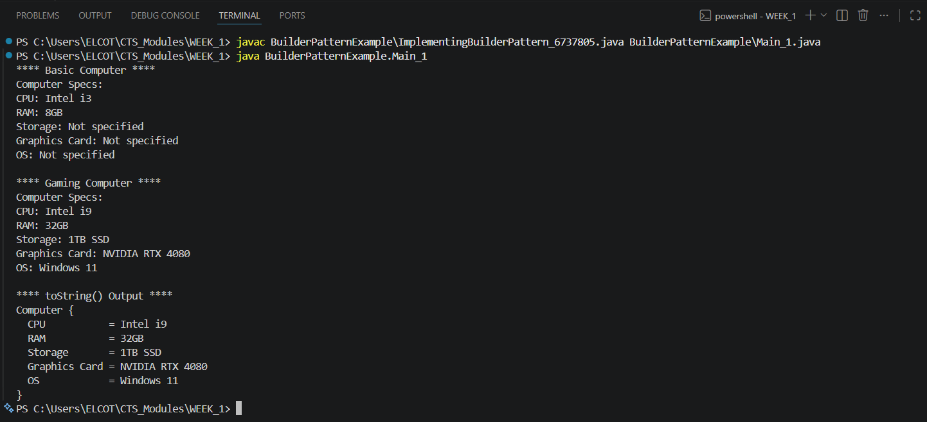

Exercise 4 : Implementing the Adaptor Pattern
Code :
package AdapterPatternExample;

interface PaymentProcessor {
void processPayment(double amount);
}

class PayPalGateway {
public void makePayPalPayment(double amount) {
System.out.println("PayPal Payment: $" + amount + " processed successfully.");
}
}

class StripeGateway {
public void chargeStripe(double amount) {
System.out.println("Stripe Payment: $" + amount + " charged successfully.");
}
}

class RazorPayGateway {
public void sendRazorPayRequest(double amount) {
System.out.println("RazorPay Payment: $" + amount + " sent successfully.");
}
}

class PayPalAdapter implements PaymentProcessor {
private PayPalGateway payPalGateway;

public PayPalAdapter(PayPalGateway payPalGateway) {
this.payPalGateway = payPalGateway;
}

@Override
public void processPayment(double amount) {
payPalGateway.makePayPalPayment(amount);
}
}

class StripeAdapter implements PaymentProcessor {
private StripeGateway stripeGateway;

public StripeAdapter(StripeGateway stripeGateway) {
this.stripeGateway = stripeGateway;
}

@Override
public void processPayment(double amount) {
stripeGateway.chargeStripe(amount);
}
}

class RazorPayAdapter implements PaymentProcessor {
private RazorPayGateway razorPayGateway;

public RazorPayAdapter(RazorPayGateway razorPayGateway) {
this.razorPayGateway = razorPayGateway;
}

@Override
public void processPayment(double amount) {
razorPayGateway.sendRazorPayRequest(amount);
}
}

public class ImplementingAdaptorPattern_6737805 {

public static void main(String[] args) {

PaymentProcessor payPal = new PayPalAdapter(new PayPalGateway());
PaymentProcessor stripe = new StripeAdapter(new StripeGateway());
PaymentProcessor razorPay = new RazorPayAdapter(new RazorPayGateway());

System.out.println("=== Payment Processing System ===\n");

System.out.println("Processing via PayPal:");
payPal.processPayment(150.00);

System.out.println("\nProcessing via Stripe:");
stripe.processPayment(250.75);

System.out.println("\nProcessing via RazorPay:");
razorPay.processPayment(399.99);
}
}

Output :
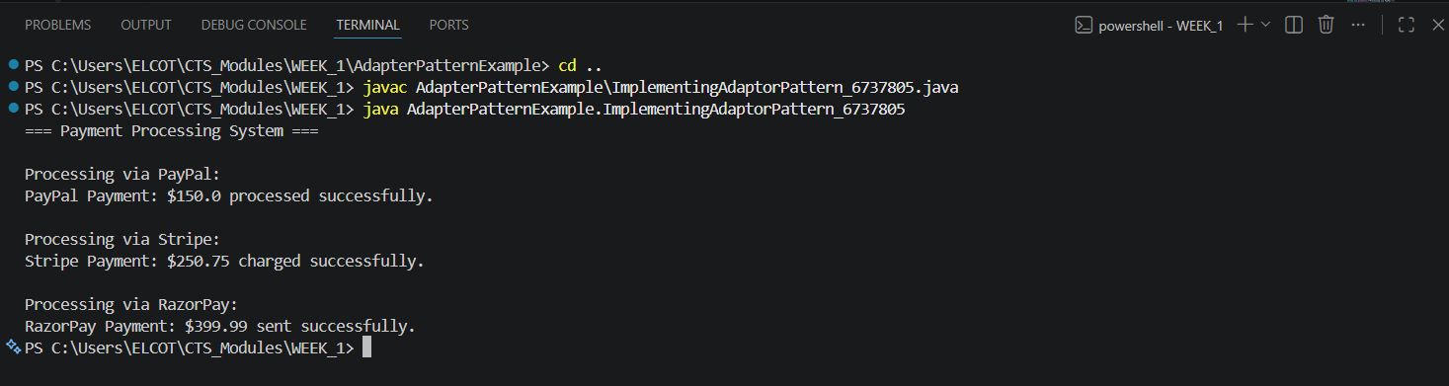

Exercise 5: Implementing the Decorator Pattern
Scenario:
You are developing a notification system where notifications can be sent via multiple channels (e.g., Email, SMS). Use the Decorator Pattern to add functionalities dynamically
Code:
interface Notifier {
void send();
}

class EmailNotifier implements Notifier {

@Override
public void send() {
System.out.println("Sending notification via Email");
}
}

abstract class NotifierDecorator implements Notifier {

protected Notifier notifier;

public NotifierDecorator(Notifier notifier) {
this.notifier = notifier;
}

@Override
public void send() {
notifier.send();
}
}

class SMSNotifierDecorator extends NotifierDecorator {

public SMSNotifierDecorator(Notifier notifier) {
super(notifier);
}

@Override
public void send() {
super.send();
System.out.println("Sending notification via SMS");
}
}

class SlackNotifierDecorator extends NotifierDecorator {

public SlackNotifierDecorator(Notifier notifier) {
super(notifier);
}

@Override
public void send() {
super.send();
System.out.println("Sending notification via Slack");
}
}

public class DecoratorPatternTest {

public static void main(String[] args) {

System.out.println("Email Notification:");
Notifier emailNotifier = new EmailNotifier();
emailNotifier.send();

System.out.println("\nEmail + SMS Notification:");
Notifier smsNotifier = new SMSNotifierDecorator(
new EmailNotifier()
);
smsNotifier.send();

System.out.println("\nEmail + SMS + Slack Notification:");
Notifier allNotifier = new SlackNotifierDecorator(
new SMSNotifierDecorator(
new EmailNotifier()
)
);
allNotifier.send();
}
}

Output :
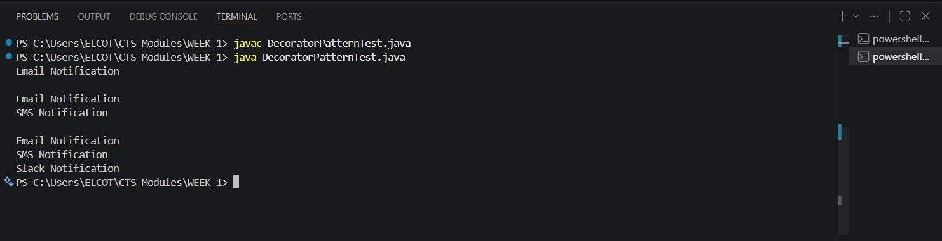

Exercise 6: Implementing the Proxy Pattern
Code:
Image.java:

public interface Image {
void display();
}

RealImage.java:

public class RealImage implements Image {

private String fileName;

public RealImage(String fileName) {
this.fileName = fileName;
loadFromServer();
}

private void loadFromServer() {
System.out.println("Loading image from remote server: " + fileName);
}

@Override
public void display() {
System.out.println("Displaying image: " + fileName);
}
}

ProxyImage.java:

public class ProxyImage implements Image {

private RealImage realImage;
private String fileName;

public ProxyImage(String fileName) {
this.fileName = fileName;
}

@Override
public void display() {

// Lazy Initialization
if (realImage == null) {
realImage = new RealImage(fileName);
}

// Cached object is reused
realImage.display();
}
}

ProxyPatternTest.java:

public class ProxyPatternTest {

public static void main(String[] args) {

Image image = new ProxyImage("Nature.jpg");

System.out.println("First Display:");
image.display();

System.out.println("\nSecond Display:");
image.display();
}
}

Output:
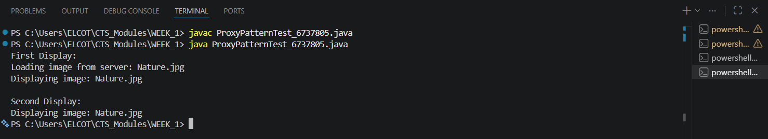

Exercise 7 : Implementing the Observer Pattern
Code :
import java.util.ArrayList;
import java.util.List;

interface Observer {
void update(String stockName, double stockPrice);
}

interface Stock {
void registerObserver(Observer observer);
void deregisterObserver(Observer observer);
void notifyObservers();
}

class StockMarket implements Stock {

private List<Observer> observers = new ArrayList<>();
private String stockName;
private double stockPrice;

public void registerObserver(Observer observer) {
observers.add(observer);
}

public void deregisterObserver(Observer observer) {
observers.remove(observer);
}

public void notifyObservers() {
for (Observer observer : observers) {
observer.update(stockName, stockPrice);
}
}

public void setStockData(String stockName, double stockPrice) {
this.stockName = stockName;
this.stockPrice = stockPrice;

System.out.println("\nStock Updated:");
System.out.println("Stock Name : " + stockName);
System.out.println("Stock Price: ₹" + stockPrice);

notifyObservers();
}
}

class MobileApp implements Observer {

private String userName;

public MobileApp(String userName) {
this.userName = userName;
}

public void update(String stockName, double stockPrice) {
System.out.println(
"Mobile App (" + userName + ") received update: "
+ stockName + " = ₹" + stockPrice
);
}
}

class WebApp implements Observer {

private String userName;

public WebApp(String userName) {
this.userName = userName;
}

public void update(String stockName, double stockPrice) {
System.out.println(
"Web App (" + userName + ") received update: "
+ stockName + " = ₹" + stockPrice
);
}
}

public class ImplementingObserverPattern_6737805 {

public static void main(String[] args) {

StockMarket stockMarket = new StockMarket();

Observer mobileUser = new MobileApp("Sudar");
Observer webUser = new WebApp("Mani");

stockMarket.registerObserver(mobileUser);
stockMarket.registerObserver(webUser);

stockMarket.setStockData("TCS", 4200.50);

stockMarket.setStockData("Infosys", 1650.75);

stockMarket.deregisterObserver(webUser);

System.out.println("\nWeb App Observer Removed");

stockMarket.setStockData("Wipro", 310.25);
}
}

Output :
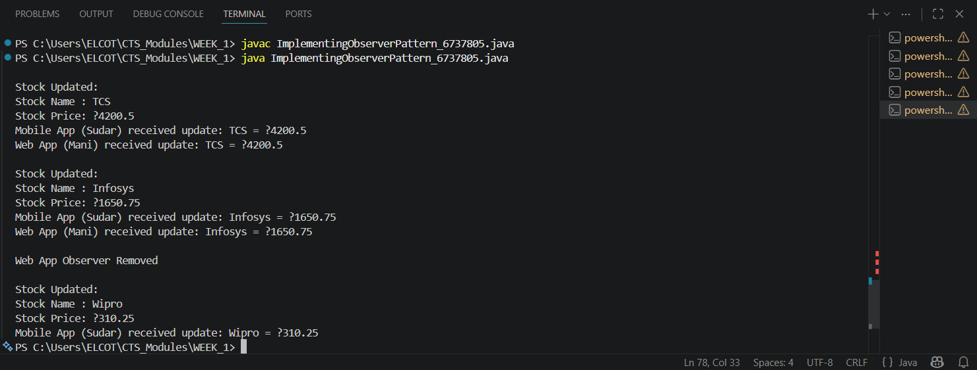

Exercise 8 : Implementing the Strategy Pattern
Code :
interface PaymentStrategy {
void pay(double amount);
}

class CreditCardPayment implements PaymentStrategy {
public void pay(double amount) {
System.out.println("Paid Rs." + amount + " using Credit Card");
}
}

class PayPalPayment implements PaymentStrategy {
public void pay(double amount) {
System.out.println("Paid Rs." + amount + " using PayPal");
}
}

class PaymentContext {
private PaymentStrategy paymentStrategy;

public void setPaymentStrategy(PaymentStrategy paymentStrategy) {
this.paymentStrategy = paymentStrategy;
}

public void makePayment(double amount) {
if (paymentStrategy == null) {
System.out.println("Please select a payment method.");
return;
}
paymentStrategy.pay(amount);
}
}

public class ImplementingStrategyPattern_6737805 {
public static void main(String[] args) {

PaymentContext context = new PaymentContext();

context.setPaymentStrategy(new CreditCardPayment());
context.makePayment(5000);

context.setPaymentStrategy(new PayPalPayment());
context.makePayment(2500);
}
}
Output :
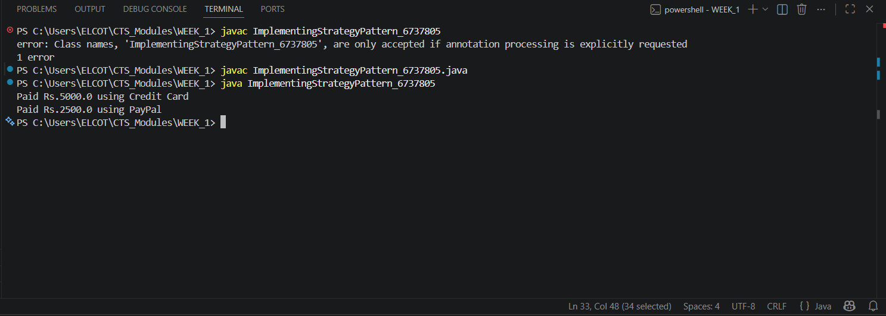

Exercise 9 : Implementing the Command Pattern
Code :
interface Command {
void execute();
}

class Light {

public void turnOn() {
System.out.println("Light is ON");
}

public void turnOff() {
System.out.println("Light is OFF");
}
}

class LightOnCommand implements Command {

private Light light;

public LightOnCommand(Light light) {
this.light = light;
}

@Override
public void execute() {
light.turnOn();
}
}

class LightOffCommand implements Command {

private Light light;

public LightOffCommand(Light light) {
this.light = light;
}

@Override
public void execute() {
light.turnOff();
}
}

class RemoteControl {

private Command command;

public void setCommand(Command command) {
this.command = command;
}

public void pressButton() {
if (command != null) {
command.execute();
} else {
System.out.println("No command assigned.");
}
}
}

public class ImplementingCommandPattern_6737805 {

public static void main(String[] args) {

Light light = new Light();

Command lightOn = new LightOnCommand(light);
Command lightOff = new LightOffCommand(light);

RemoteControl remote = new RemoteControl();

remote.setCommand(lightOn);
remote.pressButton();

remote.setCommand(lightOff);
remote.pressButton();
}
}

Output:
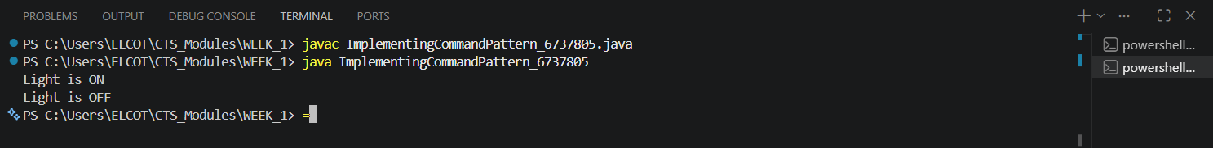

Exercise 10 : Implementing the MVC Pattern
Code :
class Student {
private int id;
private String name;
private String grade;

public Student(int id, String name, String grade) {
this.id = id;
this.name = name;
this.grade = grade;
}

public int getId() {
return id;
}

public String getName() {
return name;
}

public String getGrade() {
return grade;
}

public void setName(String name) {
this.name = name;
}

public void setGrade(String grade) {
this.grade = grade;
}
}

class StudentView {
public void displayStudentDetails(int id, String name, String grade) {
System.out.println("Student Details");
System.out.println("ID: " + id);
System.out.println("Name: " + name);
System.out.println("Grade: " + grade);
}
}

class StudentController {
private Student model;
private StudentView view;

public StudentController(Student model, StudentView view) {
this.model = model;
this.view = view;
}

public void setStudentName(String name) {
model.setName(name);
}

public void setStudentGrade(String grade) {
model.setGrade(grade);
}

public void updateView() {
view.displayStudentDetails(
model.getId(),
model.getName(),
model.getGrade());
}
}

public class MVCPattern_6737805 {
public static void main(String[] args) {

Student student = new Student(101, "Sudar V.", "A");
StudentView view = new StudentView();
StudentController controller =
new StudentController(student, view);

System.out.println("Initial Details:");
controller.updateView();

controller.setStudentName("Sudar V.");
controller.setStudentGrade("A+");

System.out.println("\nUpdated Details:");
controller.updateView();
}
}

Output :
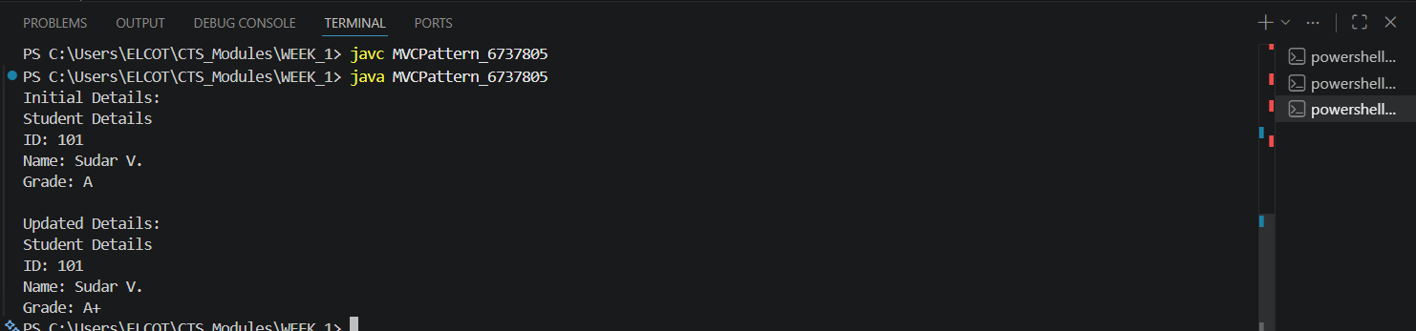

Exercise 11 : Implementing the Dependency Injection
Code :
interface CustomerRepository {

String findCustomerById(int id);
}

class CustomerRepositoryImpl
implements CustomerRepository {

@Override
public String findCustomerById(int id) {

if (id == 101) {
return "Sudar V.";
}

return "Customer Not Found";
}
}

class CustomerService {

private CustomerRepository repository;

public CustomerService(CustomerRepository repository) {
this.repository = repository;
}

public void getCustomerDetails(int id) {

String customer =
repository.findCustomerById(id);

System.out.println("Customer ID : " + id);
System.out.println("Customer Name : " + customer);
}
}

public class DependencyInjection_6737805 {

public static void main(String[] args) {

CustomerRepository repository =
new CustomerRepositoryImpl();

CustomerService service =
new CustomerService(repository);

service.getCustomerDetails(101);
}
}

Output :
